-EXERCISE 2 STAR TOPOLOGY:

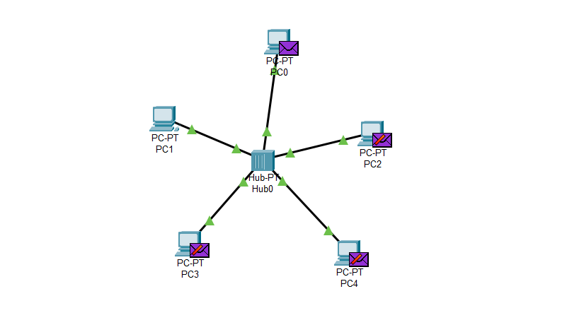

-EXERCISE 3 BUS TOPOLOGY:

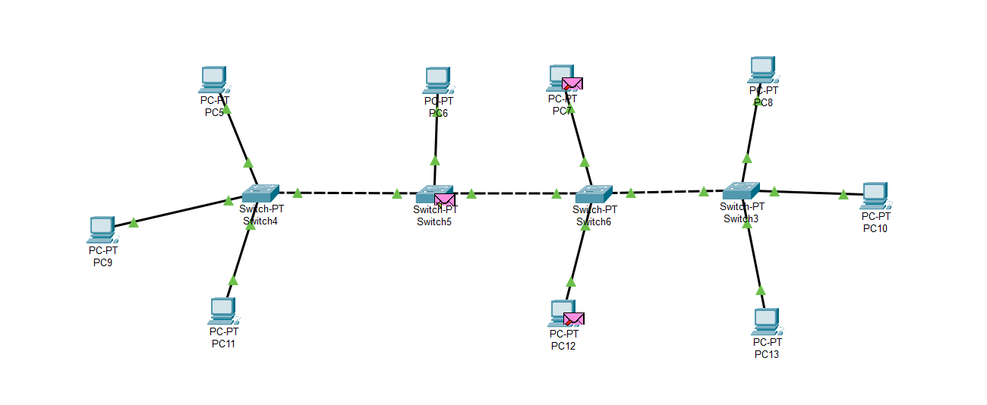

-EXERCISE 4 RING TOPOLOGY:

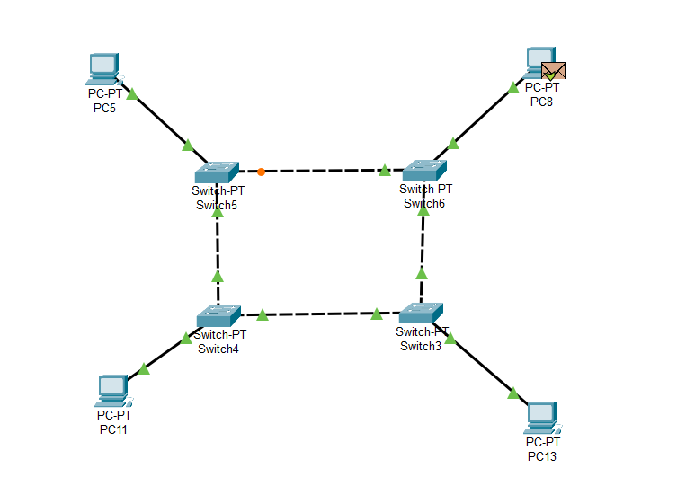

-EXERCISE 5 MESS TOPOLOGY:

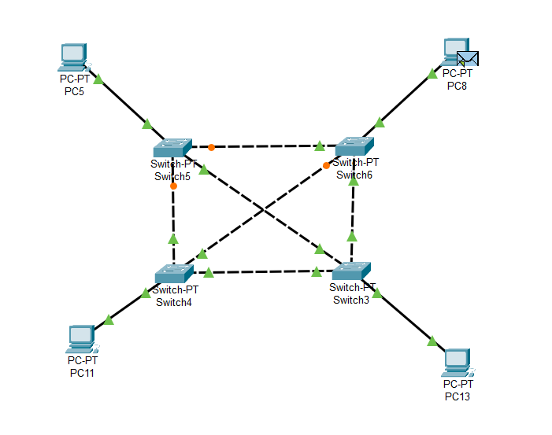

-EXERCISE 6 TREE TOPOLOGY:

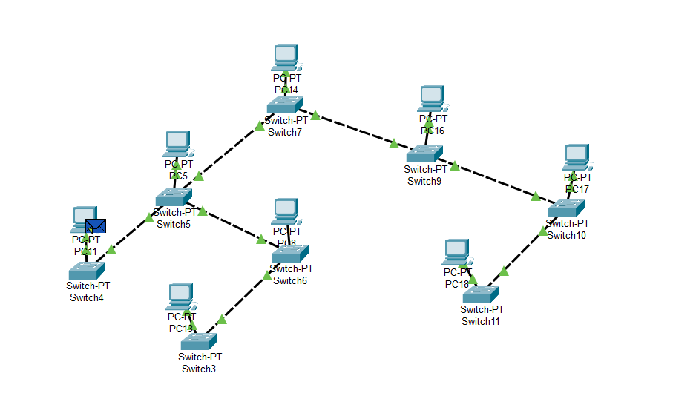

-EXERCISE 7 HYBRID TOPOLOGY:

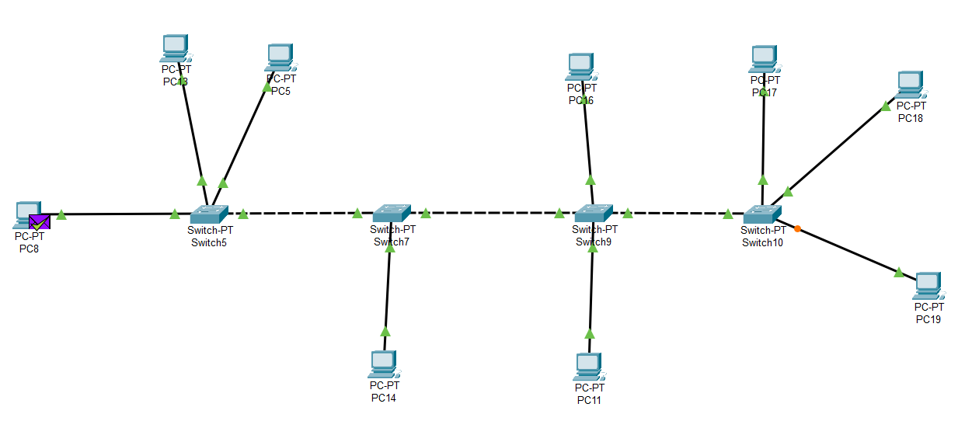

-EXERCISE 8 ARP TOPOLOGY:

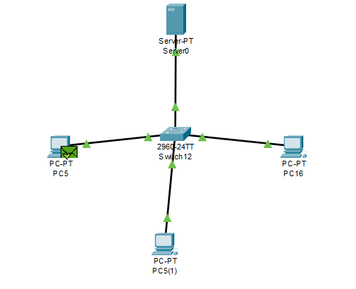

-EXERCISE 9 CSMA TOPOLOGY:

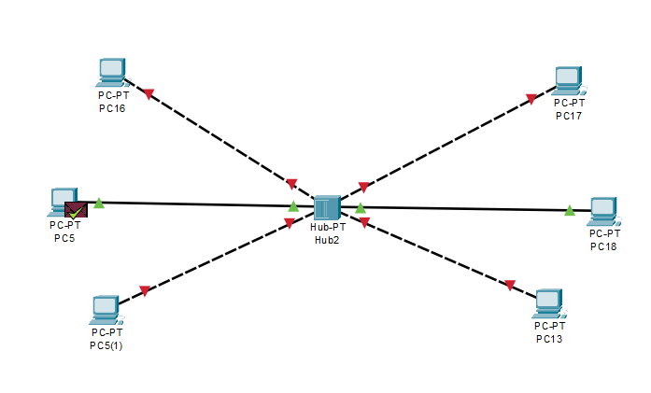

-EXERCISE 10 COMPUTER LAB:

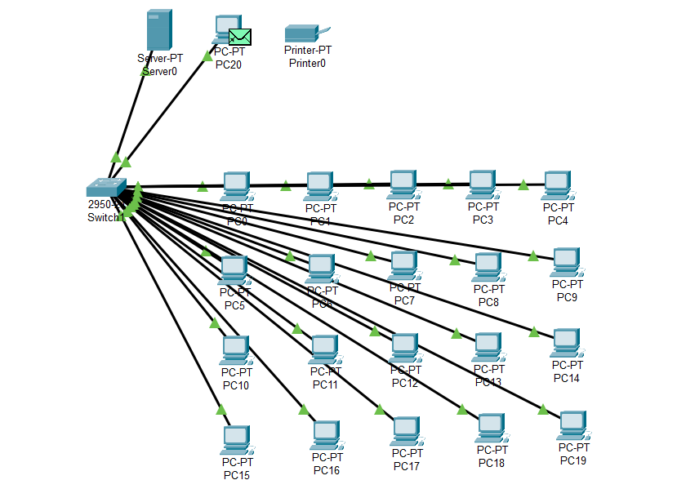

-EXERCISE 11

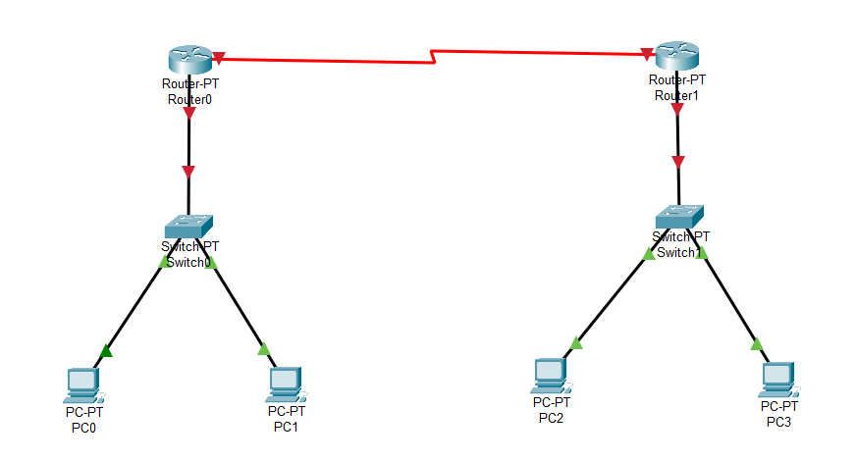

-EXERCISE 12

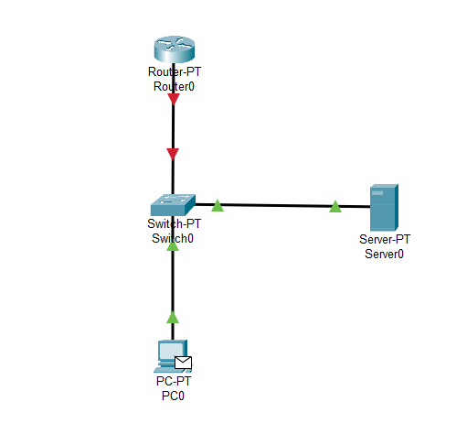

-EXERCISE 13

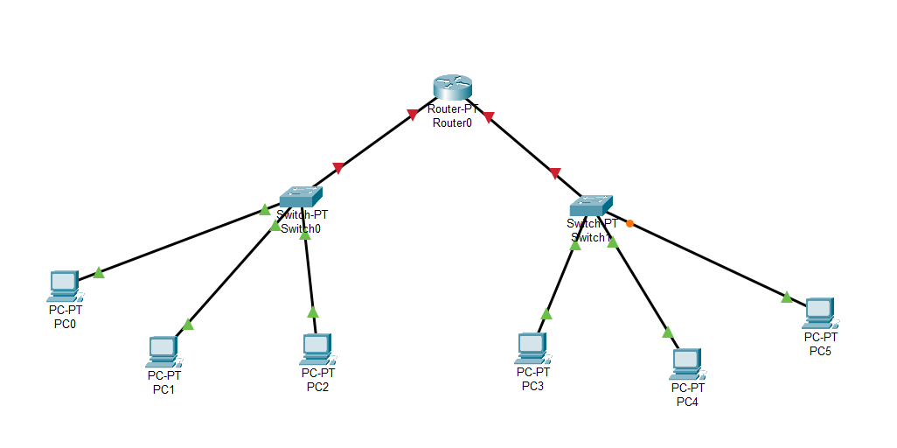

-EXERCISE 14

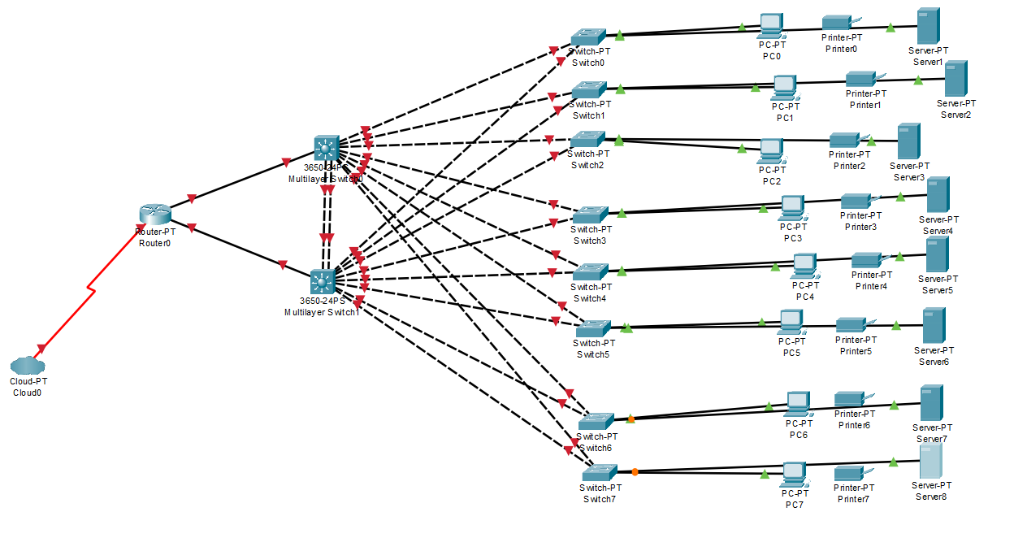

-EXERCISE 15